System Architecture of EntrySense

- IoT Elements
The IoT element is a Raspberry Pi 4 connected to a magnetic reed switch (door contact sensor) and a status LED. The reed switch provides a digital open/close signal via a GPIO input using an internal pull-up resistor. The Pi runs a Python service that reads the sensor state and publishes events (e.g., door opened/closed) to PubNub. The Pi also listens for remote commands (arm/disarm) and updates local indicators (LED) accordingly.
- Web Server
The web server stack consists of:
- Nginx as the public-facing reverse proxy handling HTTPS (TLS), domain routing, and static asset delivery.
- A backend web application (your API/service) running behind Nginx, responsible for authentication, device management, ingesting events from PubNub (or consuming PubNub events), and serving application endpoints to the frontend.
Nginx terminates TLS and forwards only trusted requests to the backend over the internal network.
- Database
The database stores persistent application data such as:
1. user accounts (email, hashed password, full name),
2. device state (armed/disarmed),
3. event history (open/close/arm/disarm with timestamps and descriptions).
The database is not publicly exposed; only the backend can access it over a private connection.

- Flow of Data
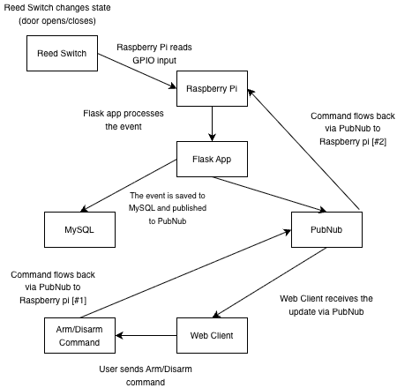
- Security in transit & at rest
In transit
- All web traffic between users and the server is protected with HTTPS (TLS) via Nginx.
- PubNub communication uses encrypted transport (TLS), protecting messages between the Raspberry Pi and the PubNub network.
- Database traffic is restricted to private networking (backend ↔ DB only). If DB connections traverse a network interface, TLS can be enabled, but the primary control here is network isolation + strong credentials.
At rest
- Passwords are stored as hashed + salted values (never plaintext).
- Database access is protected using least-privilege credentials (backend user with only required permissions).
- Server secrets (DB password, PubNub keys, JWT secret) are stored in environment variables and not committed to source control.
- Access to the Raspberry Pi is restricted (SSH keys, changed default credentials), and the device runs only required services.

- Fritzing Sketch
Unable to create fritzing sketch because the application does not have magnetic reed switch that is used in this project

